**CSA-0805-PYTHON PROGRAM**

**LEVEL- 1**

**NAME:-P.KARTHIK REDDY DATE:-15/10/25**

**REG NO:-192472181 SUBJECT:-Python**

1. Read the number until -1 is encounter. find the avg of positive numbers and

negative numbers entered by user

Sample Input:

Enter -1 to exit, enter the numbers 7,-2,9,-8,-6,-4,10,-1

Output: avg negative number is -5, avg positive number is 8

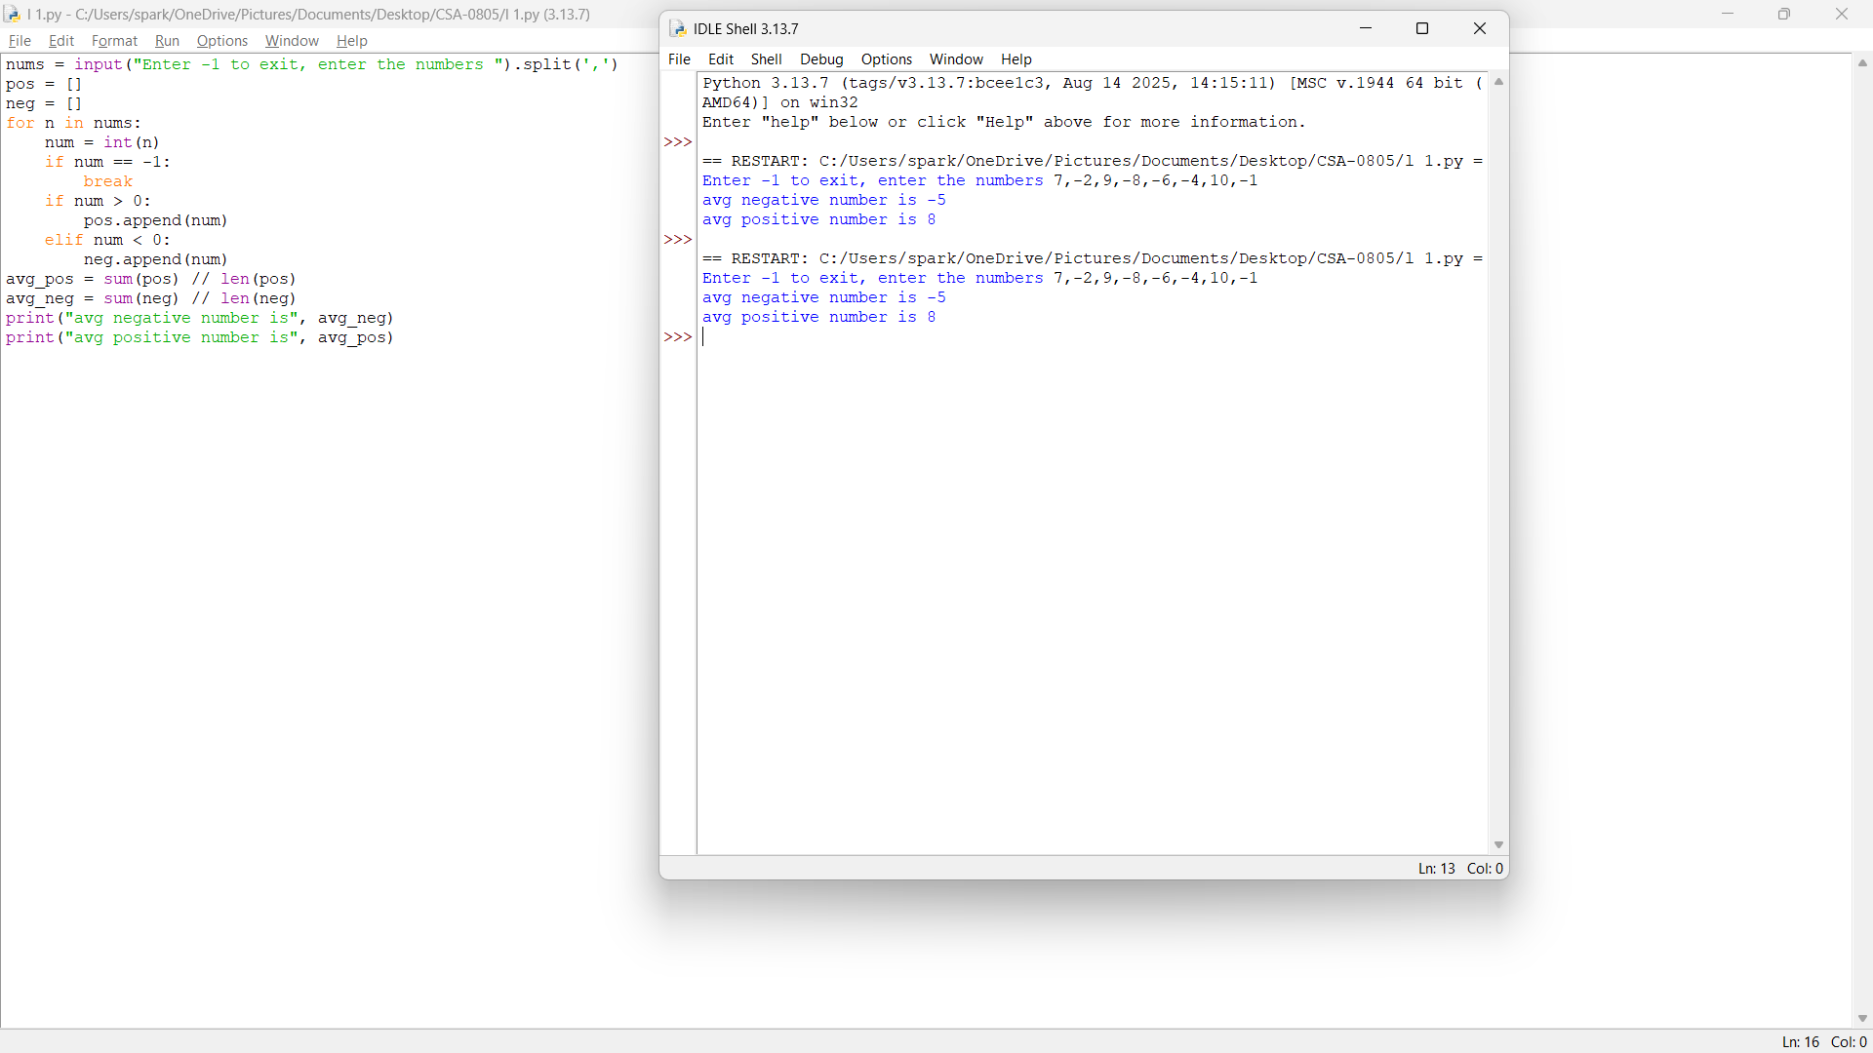

2.Write a python program to find the square, cube of the given decimal number. Sample Input:

Given Number: 0.6

Output:

Square Number: 0.36

Cube Number:0.216

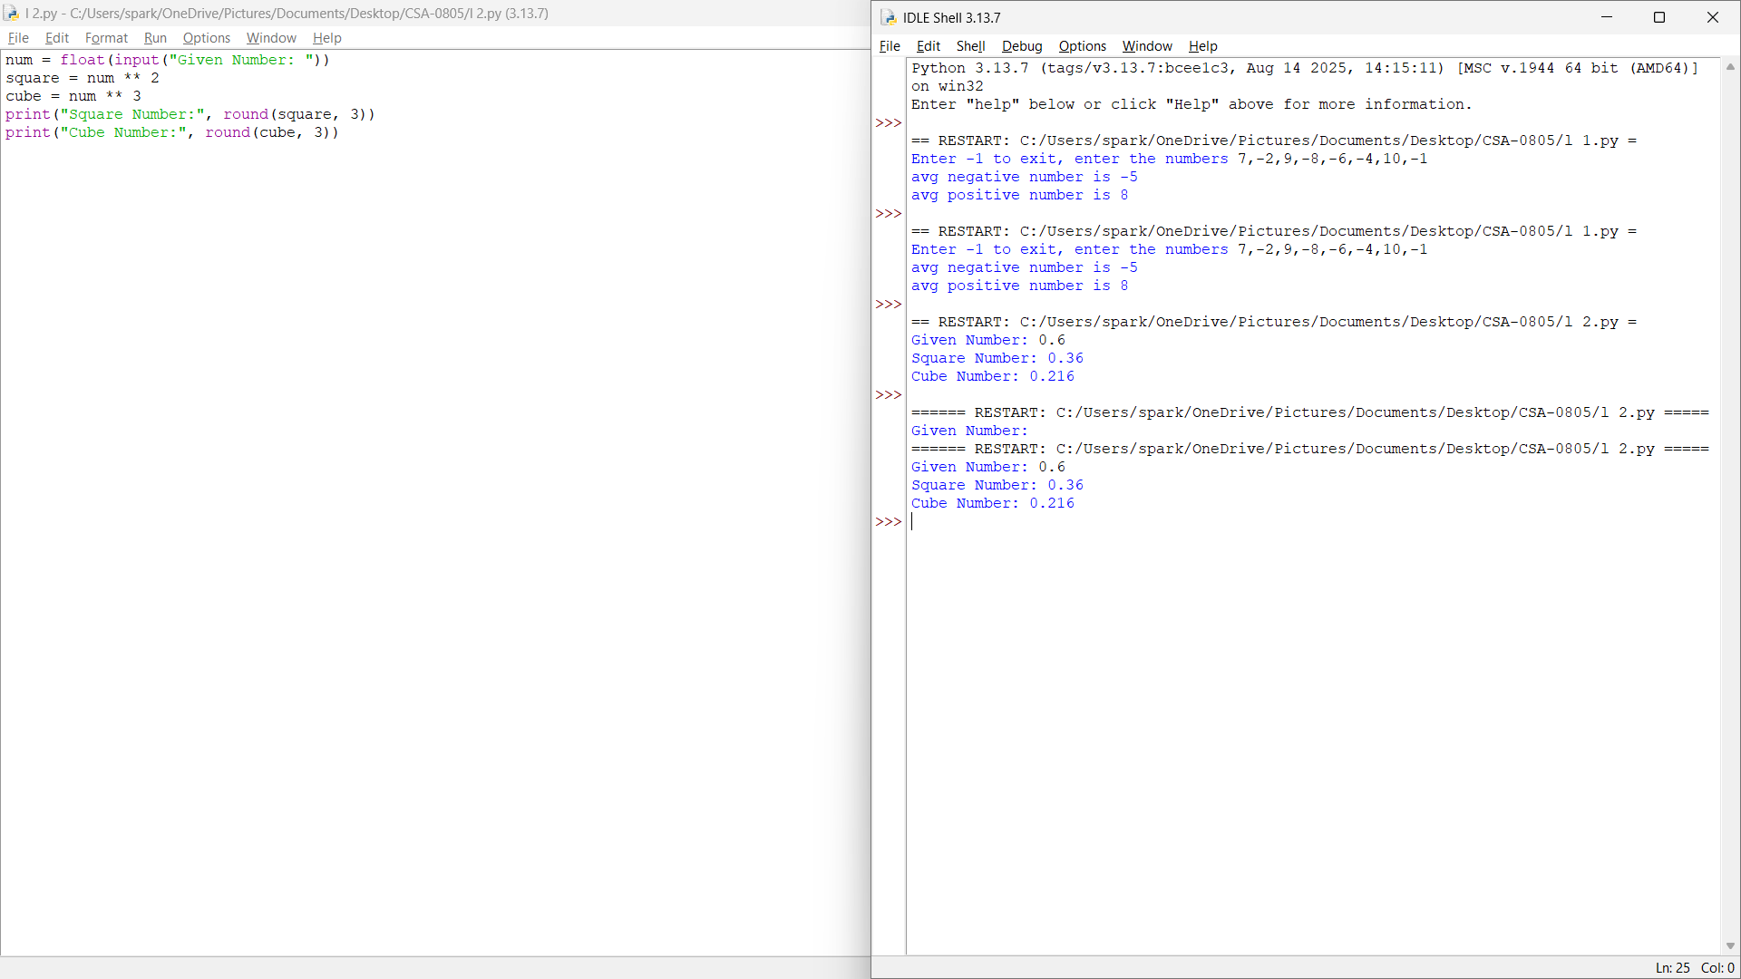

3.Write a python program to print the following pattern.

Sample Input:

Enter the Character to be printed:+

Number of rows.: 5

Output:

+

+ +

+ + +

+ + + +

+ + + + +

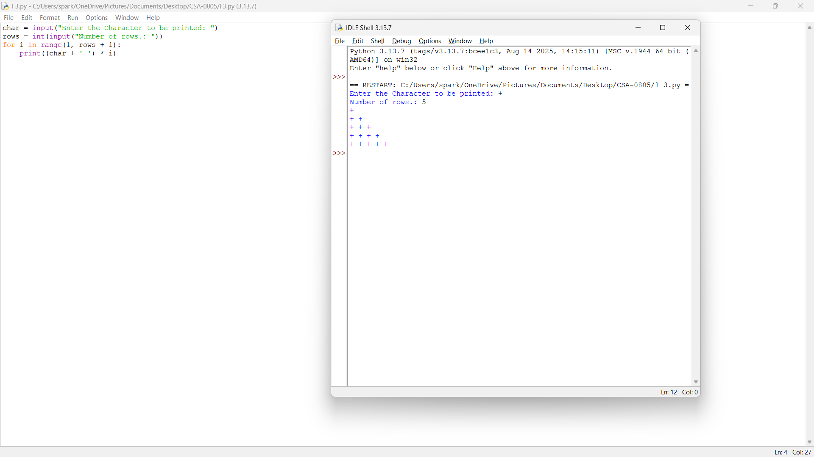

4.Python Program to Display the Multiplication Table

Sample Input:

A=7

B=5

Output:

7 x 1 = 7

7 x 2 = 14

7 x 3 = 21

7 x 4 = 28

1. x 5 = 35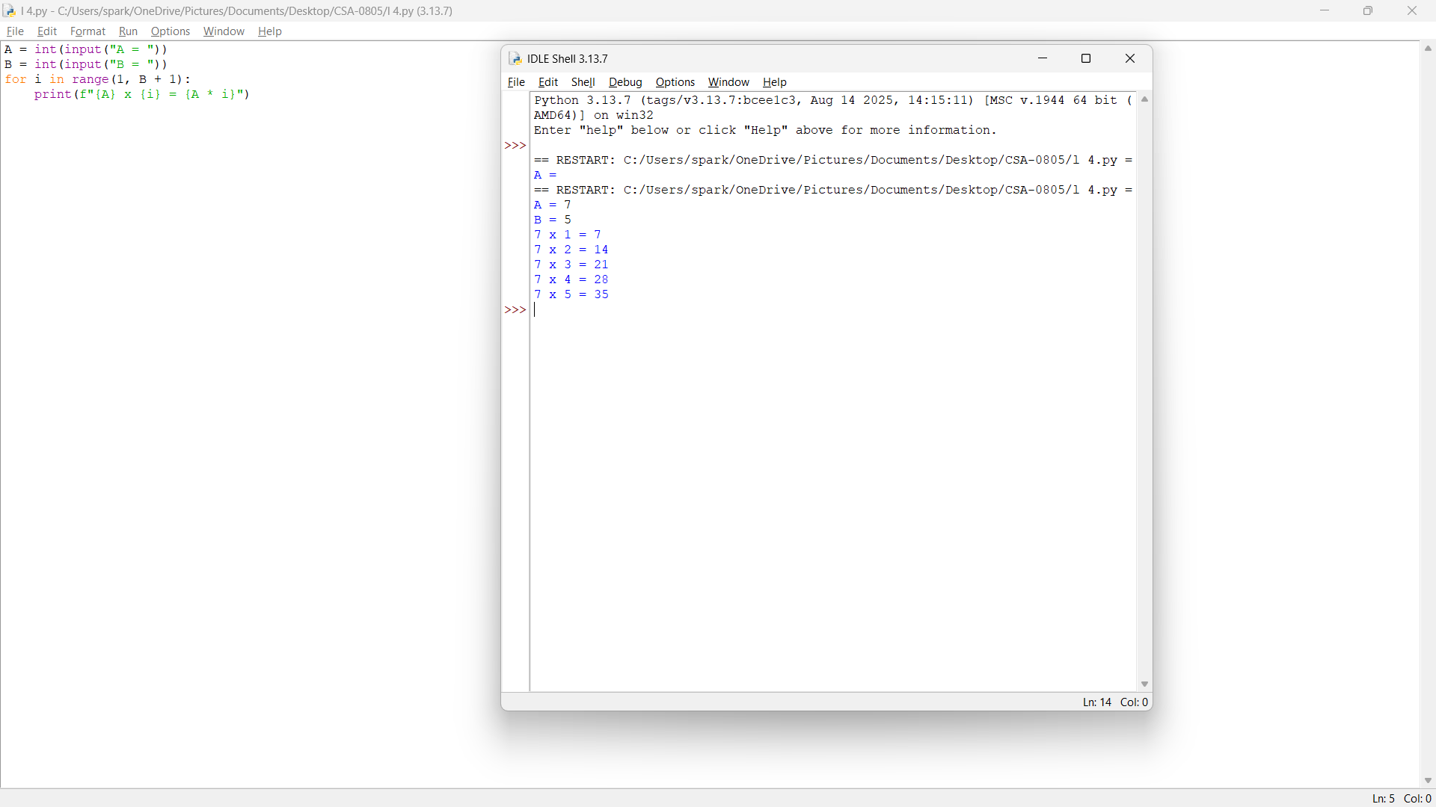

5.Write a program to find whether it is leap year or not?

Sample Input: 2000

Output: Leap Year

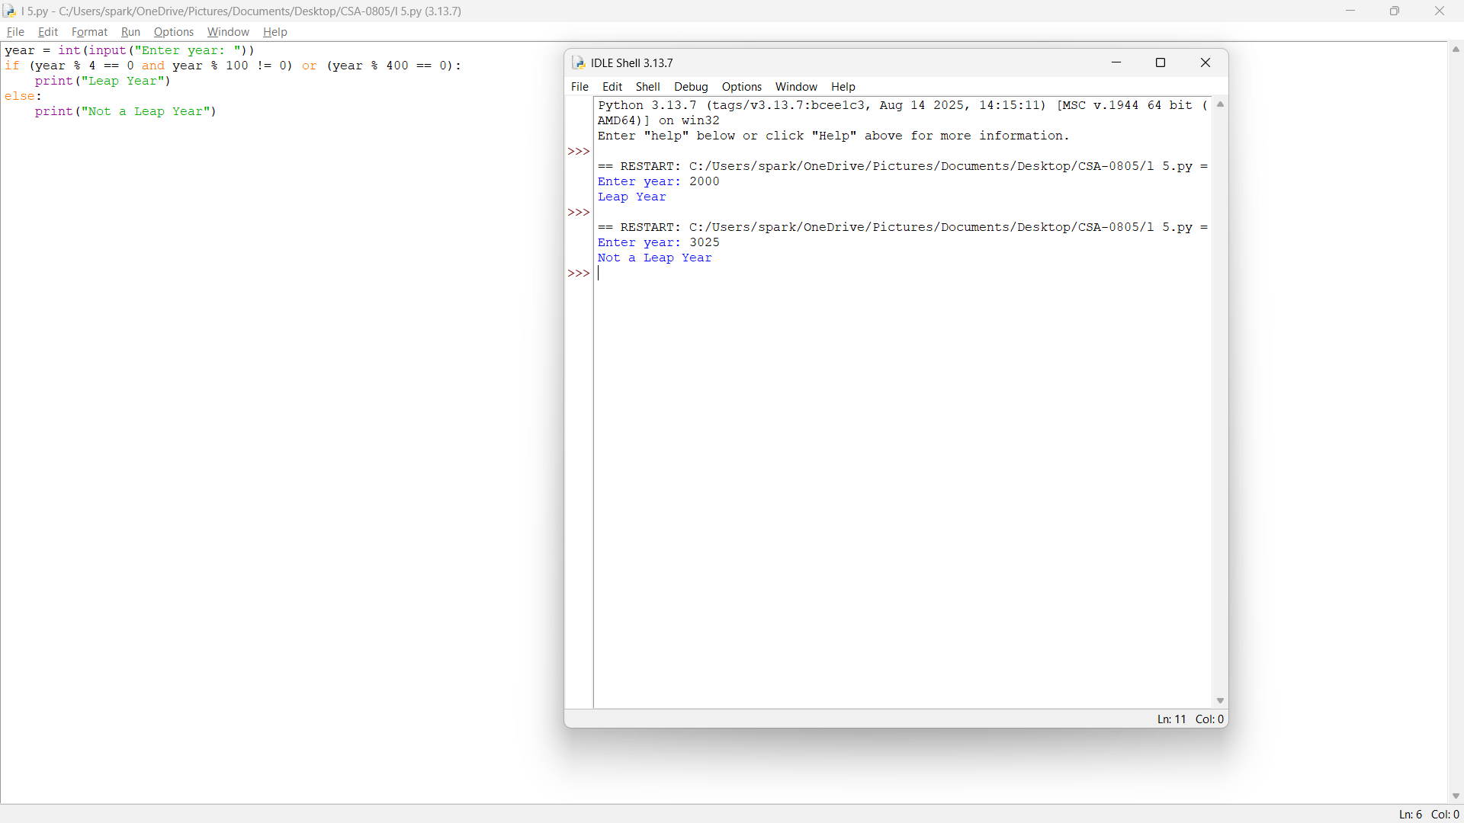

6.Write a program to find out the duplicate array

Sample Input: array={1,2,3,4,1}

1. Output: duplicate array={1,2,3,4}

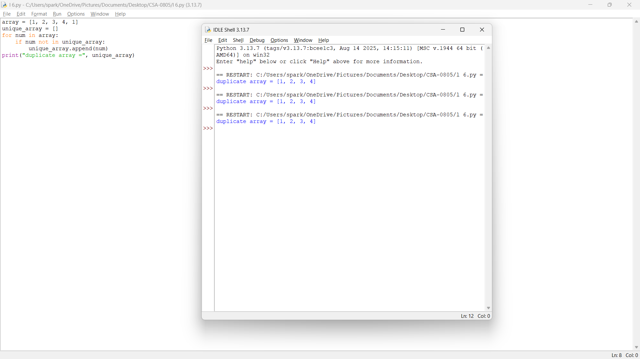

7. Check whether the number is positive or negative

Sample Input:23

Output: positive

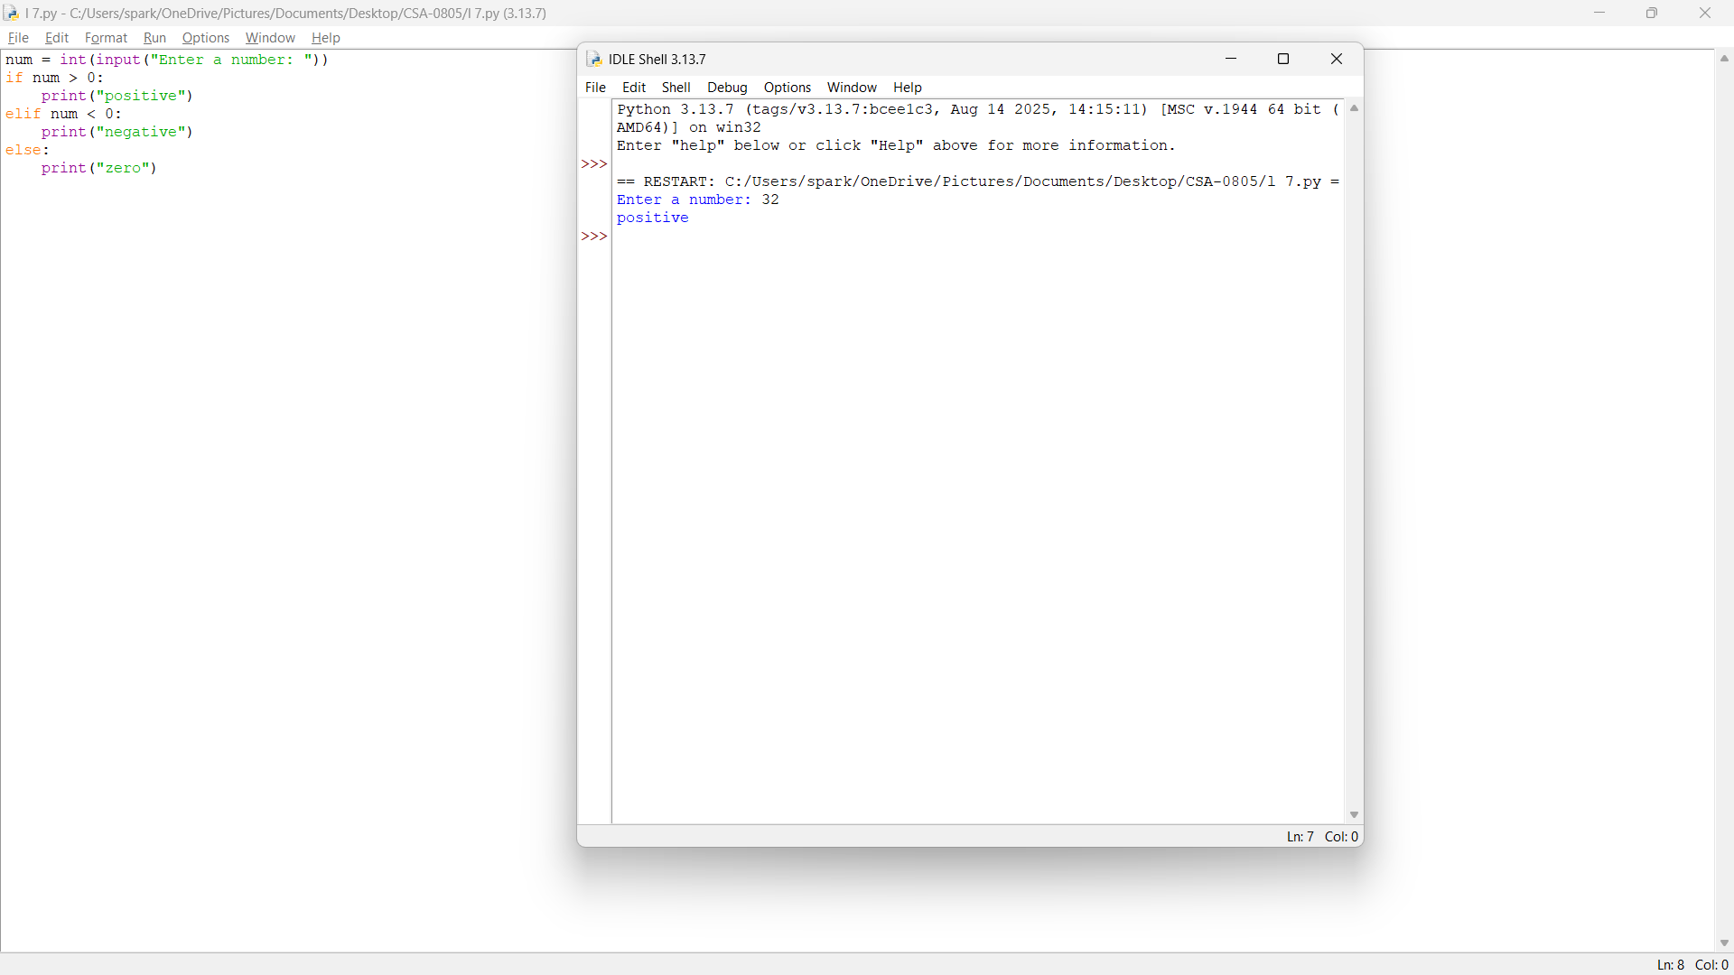

8.Write a python program to find the average of mean median mode

Sample Input: [12,45,83,52]/4

1. Output: utput:48

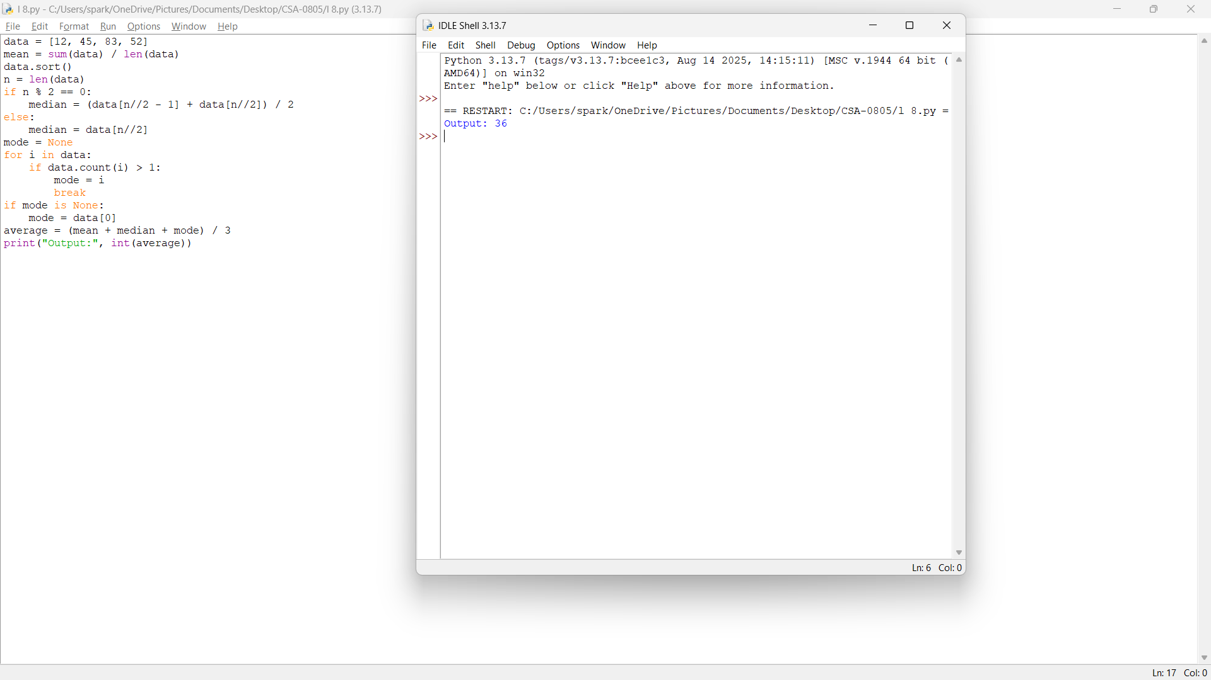

9.Write a python program to store the arrays in non-increasing order

Sample Input:[1,8,3,4,0]

1. Output:[8,4,3,1,0]

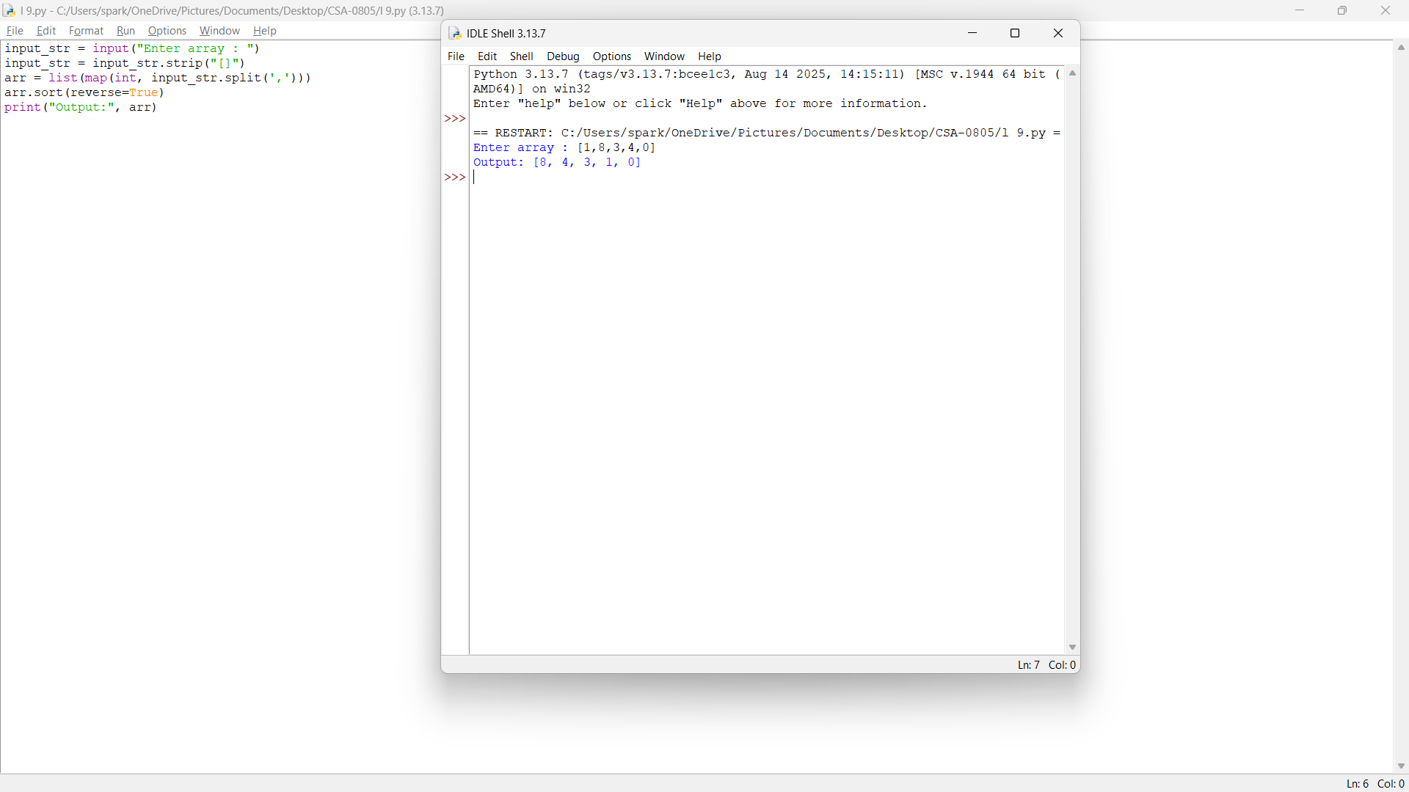

10.Write a Python Program to Intersecting an elements

Sample Input:

(2,3,4,5)

(3,4,8,6)

Output:

1. (3,4)

